**Scratch step by step**

1. Open Scratch 1.4.
2. Open the Scratch quiz ‘template’.
3. Select the bear sprite

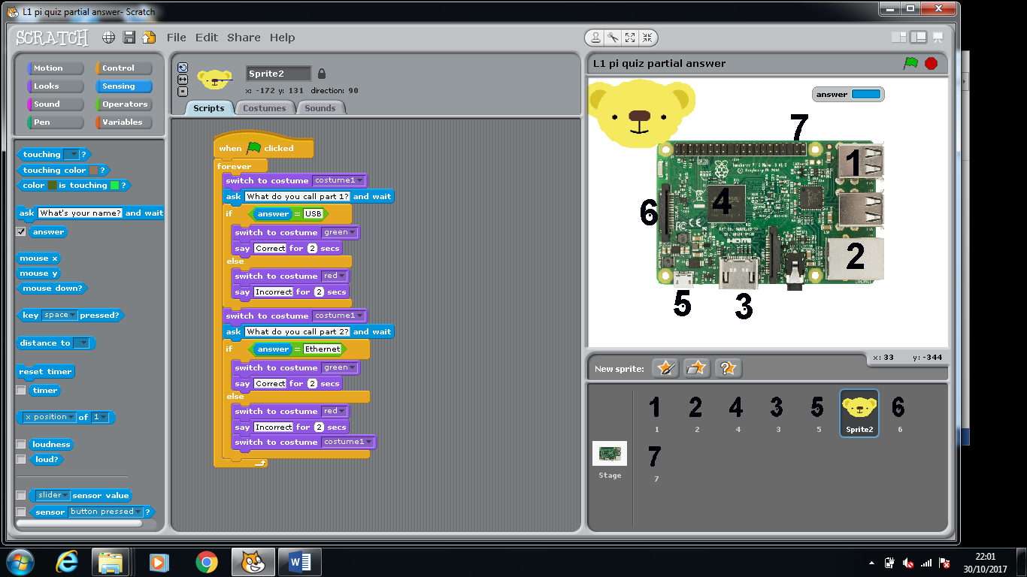

1. In the ‘scripts’ tab you will now start to drag in your instructions:

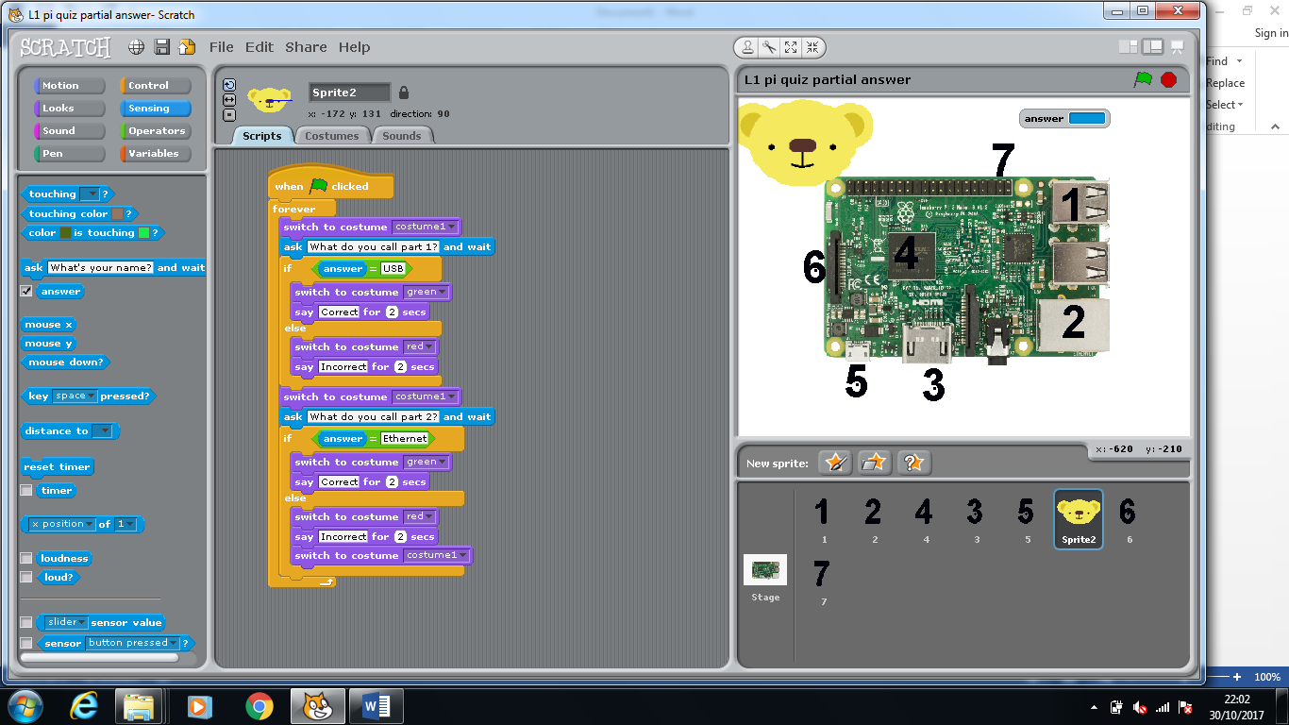

1. Select the ‘Control’ commands and select the when ‘When green flag clicked’ and forever loop block

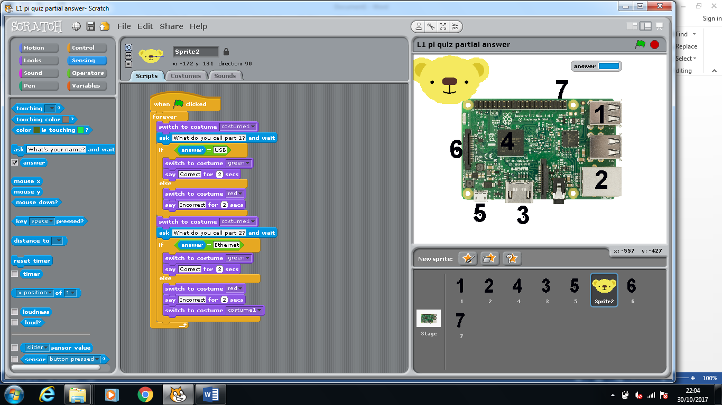

1. Next select the ‘Looks’ commands and select the ‘switch costume to ….’ Then select costume 1.



1. Select the ‘Sensing’ commands. Then choose the ‘ask …. and wait ’ block. Type in ‘what do you call part 1?’

Recap So far your program shows costume 1 see the costumes below:

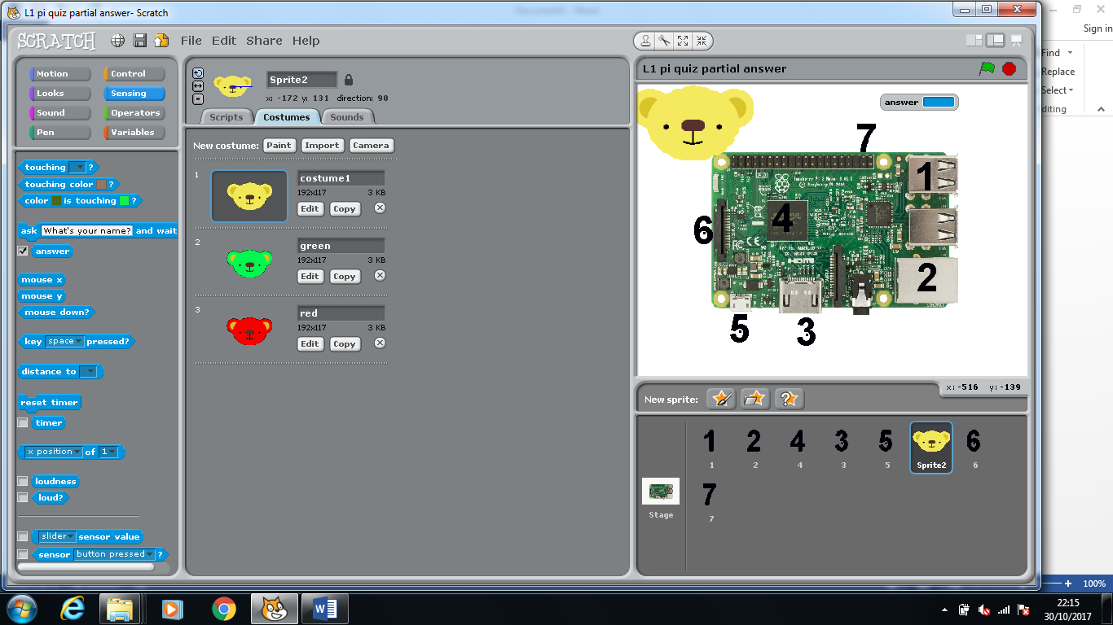

Then it asks a question and waits for your user to type in an answer.

1. Select the ‘Control’ commands and drag in the ‘if …. Else block’



1. Next up select the ‘Operators’ commands and select the green hexagon which looks like the one below, in the right hand box type ‘USB’ in the left one you need to drag in the ‘answer’ block from the ‘Sensing’ commands it should end up looking like picture b.

a)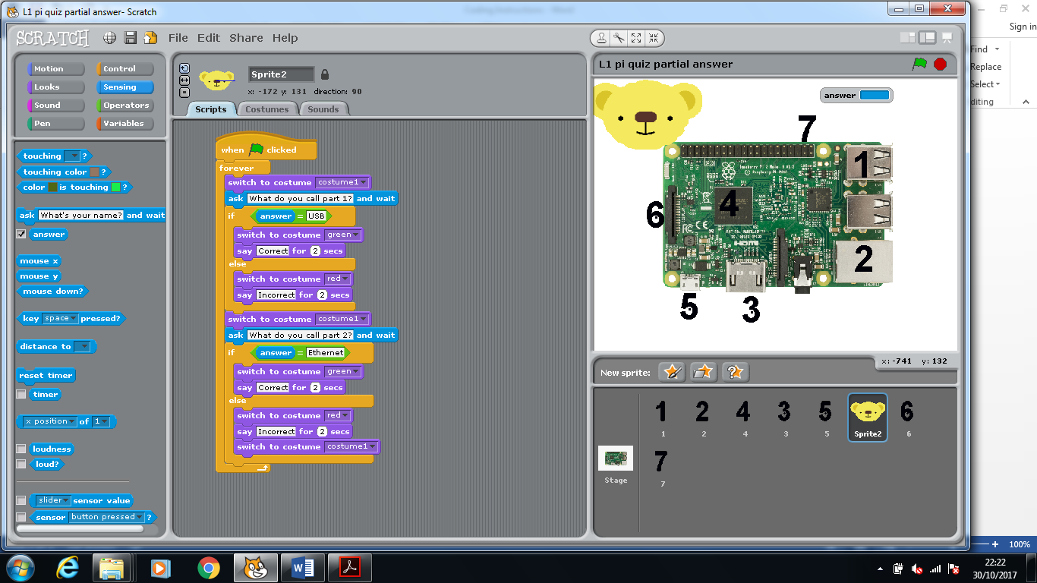

b)

1. Next up we are going to create the actions if the users answer is USB then we want the bears face to appear as green and output the message ‘Correct’. You will need to grab these commands from the ‘Looks’ commands. It should end up looking like below:

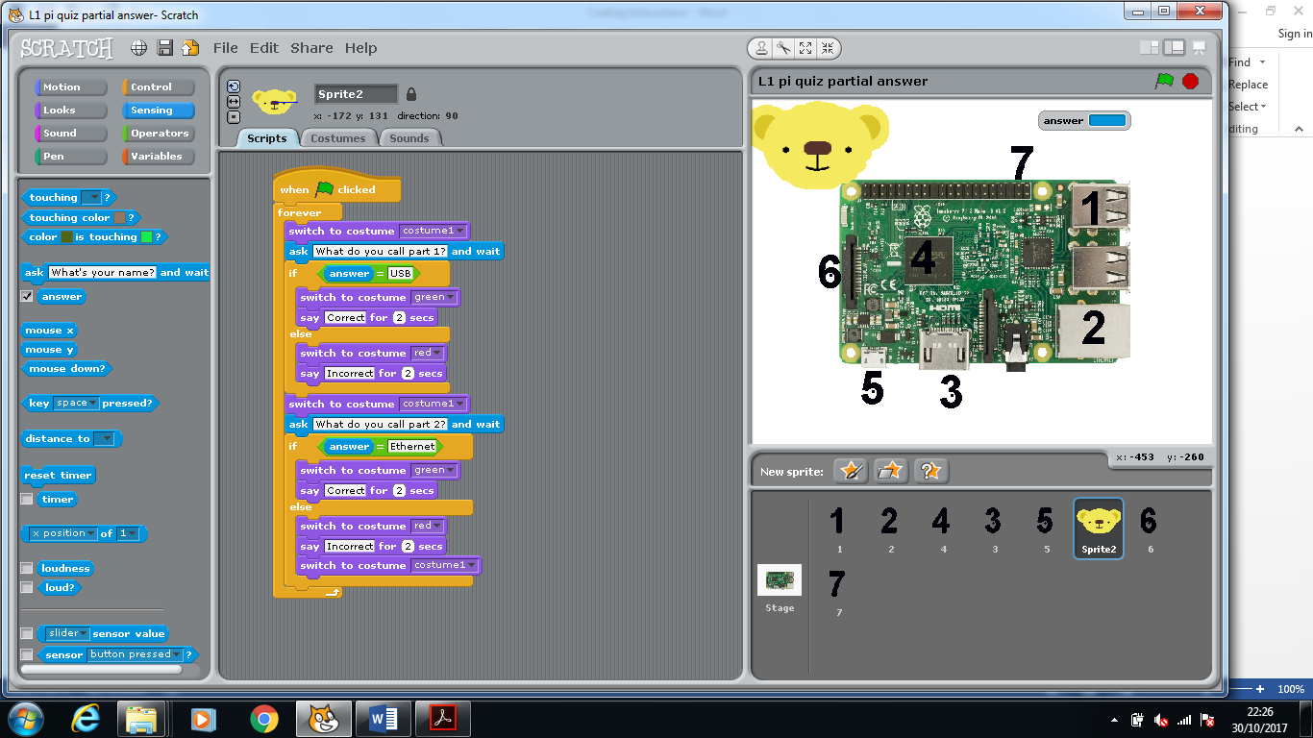

1. Next we need to sort the else actions, in this case else should change the bears face ‘red’ and output the message ‘’. Again you will find these blocks in the ‘Looks’ commands. It should end up looking like below:



1. Next we want reset the bear to normal so we can ask the next question so we set costume to ‘costume 1’. Then we ask the next question as we did previously.



1. The whole process now gets repeated to deal with processing the next answer like below…



For every question that you want to ask you will need to repeat these steps. Now complete the remaining questions. Hint if you duplicate(right click > duplicate) the code you will save yourself time.